Show and Tell: What Can Chimps Tell Us?

News to Know

by Dr. Elizabeth Mitchell

June 17, 2013
Layman
- author-elizabeth-mitchell
- children
- human-evolution
- language-capability
- news-to-know
- primates

Daily Mail: Can toddlers and apes teach us lessons about how language evolved?
Are there “striking similarities” in ape and human communication, and what do they mean?
Parents eagerly await their child’s first word, recording the age at which their little one joins the verbal world of his or her elders. Speech is a developmental milestone and a uniquely human ability. Psychologists who just published their analysis of the expressive triumphs of a toddler, a chimp, and a bonobo in Frontiers in Psychology, however, are concerned not so much with the way a child learns to speak as with the implications of language acquisition for the evolutionary origins of human language.
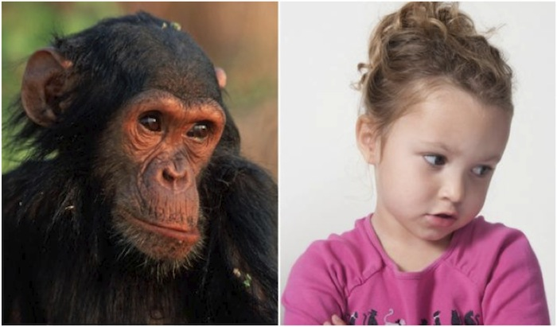Children and apes being raised by humans know that holding up their arms to be picked up usually works. Does that mean this ape is harboring complex abstract thoughts just needing a better mode of expression? Do a few common gestures show that humans and apes acquired those gestures from a shared ancestor? Image: www.dailymail.co.uk
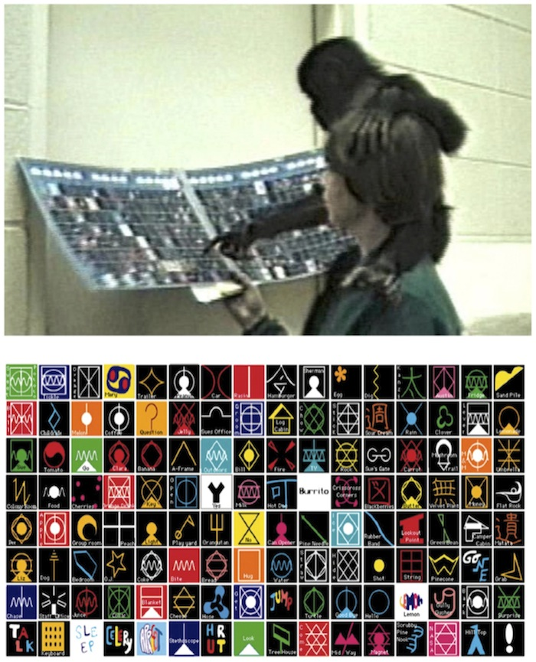Apes were taught to associate each “lexigram” symbol with its meaning and a spoken word. Image: www.frontiersin.org
Evolutionists believe human linguistic ability evolved but debate how. Nevertheless, like many evolutionary linguists, the authors of “A cross-species study of gesture and its role in symbolic development” cling to the notion that a child learning to talk recapitulates the evolutionary steps that ape-like ancestors trod as they learned to speak and think abstractly. They grasp at any ape-human similarities as support for their position.
The authors believe gestures not only provide a scaffold to help a child build the ability to speak but also mimic evolutionary steps taken by our ancient ape-like ancestors. “Because behaviors such as language and gesture do not fossilize,” they acknowledge, “evolutionary links between gesture and language are impossible to prove.”¹ Nevertheless, they say their findings support “the gestural theory of language evolution.”¹ They claim “strikingly similar” human, chimp, and bonobo gestures provide reliable evidence that a common ape-like ancestor communicated using gestures and developed a latent linguistic capacity. They maintain that evolving humans with this latent ability transformed innate gestures into speech. In other words, they believe that gestures provided a scaffold on which an ape-like ancestor grunted his way up the evolutionary tree to become human.
The researchers videotaped a little girl for one hour per month from age 8 ½ months until she was nearly two years old. They compared these videos with video footage of a chimp and a bonobo being raised in “language enriched environment [which] included ongoing activities wherein caregivers and apes communicated through gestures, lexigrams, and vocalizations, as well as daily language-testing sessions.”¹ Lexigrams (see illustration) are “arbitrary visual symbols representing words.”¹ When a lexigram was pressed, a person or electronic voice said the word. “As with human children, lexigram symbols were learned within the context of ongoing activities that were relevant to the apes.”¹
The apes’ use of lexigrams was considered equivalent to the child’s use of spoken words. After the apes were trained to associate lexigrams with their meanings, they sometimes used them to make requests. The researchers “hypothesized that all three species would exhibit a shift from greater reliance on gestures to greater reliance on symbolic communication with development”¹and wrote, “Such evidence would support the gestural theory of the evolution of language.”¹The child of course learned to use “spoken symbols” (i.e., to talk). However, the apes actually failed to support the theory, for the apes “continued to communicate more frequently by gesture than by symbol.”¹
The psychologists noted whenever a gesture was used alone and later combined with a spoken or pictographic symbol. This pattern was viewed as support for the theory of language acquisition through gestures. Though the researchers praised their apes for using this gesture-symbol approach to learning, they admitted that it was “statistically significant only for the child.”¹
Dr. John Oller, Jr., an expert in the field of language acquisition and communication disorders (especially autism),² describes this as only one of many examples in which “it seems that the researchers were willing to go to great lengths to try to find similar patterns even where all they got were contrasts. The gaps were so evident that only by cherry picking and strange manipulations of their data were they able to get the apes on the same scale as the human subject.”³
Furthermore, despite coauthor Patricia Greenfield’s assertion, “The similarity in the form and function of the gestures in a human infant, a baby chimpanzee and a baby bonobo was remarkable,” the child’s repertoire of “gestures” was incomparably richer than the apes’. There were a few gestures common to both child and apes, as well as some unique to each. Common gestures included reaching for a desired object, pointing to an object—which is often observed in apes and even dolphins raised in a language-rich captivity¹—and holding up the arms to be picked up. “Head-pointing”—which only occurred once for the child and once for one ape—was also classified as a common gesture.¹
The “list” of gestures unique to the apes was rather short. Once the chimp held its palm outstretched, and once the chimp guided the caregiver’s hand to the object she wanted. (That’s the whole list.) The researchers also tried to credit the apes with additional communicative behavior—such as responding to speech, demonstrating awareness of whether they had a human’s attention, and making eye contact to let the human know they were trying to communicate. Dr. Oller notes that trained dogs do the same, “but no one would claim that the dog is an immediate ancestor of humans or that barking preceded speech.”³
The child, on the other hand, displayed a wealth of meaningful unique gestures. She held up objects for her parents to see, nodded, shook her head, mimed twisting a doorknob to indicate open, waved, and used the finger-to-pursed lips symbol for shhh. The study’s authors indicated that substantial gestural similarities in the three species would support their theory.¹ But despite the success they claim, the data they report shows just the opposite. In addition to the unique gestures produced by this toddler, Dr. Oller notes that infants exhibit “smiling, laughing, facial expressions” and even “vocal turn-taking at birth.”⁴ Apes certainly fail to meet these demands upon their evolutionary cousin-ship.
Dr. Oller considers the researchers’ hypothesis—the idea that language development in a child recapitulates linguistic evolutionary steps—“unworkable.” Commenting on their “evidence,” he says,
All in all, the authors made an incredible effort to force an unworkable theory to accommodate their uncooperative data. The facts just don't support their preconceived ideas. Even when viewed through the distorted telescopic lenses of orthodox evolutionists, the kind that can supposedly see across “five to six” millions of years, the facts still show that the human child is equipped to use abstract symbols in interactions with others and, as they acknowledge, “to share experience for its own sake” (p. 10),¹ [something apes do not do].
The authors, however, find themselves at fault for the failure of their apes to compete with the uniquely human symbolic capacity: [they write,] “Given limitations of the lexigram system devised to help apes communicate with us, compared with the flexibility of human speech, gestures may be a better match than symbols for apes but not humans.”^{1,3}
The limitations of a gestural language can’t get apes off the hook, though. Deaf persons adept at sign language manage to communicate using a gestural language quite nicely. Dr. Oller notes that scientific research has for decades demonstrated that humans can communicate effectively even when confined to a language of gestures. He says,
Humans excel in the use of gestures too! Did they [the authors] miss the last several decades of teaching pidgin signed languages to chimps and gorillas? It came out from all that work that deaf humans outperform apes in sign language expressions just about exactly as much as any humans outperform apes in the use of anything resembling symbolic communication.
Humans, unlike animals, are designed with an innate linguistic capacity. When children speak they are using symbols to communicate abstract ideas they already have, Dr. Oller explains. “Abstract concepts precede the use of words. . . . Children have to have the abstract ideas, the symbolic wherewithal first, before any language acquisition occurs.”³
The authors write, “Gestures seem to provide a foundation for each new stage in early linguistic development,”¹ but Dr. Oller notes that Noam Chomsky (the father of modern linguistics) ”has even argued that all the concepts for language have to be in place before any language acquisition can occur.”
The language counterfeit seen in these animals differs markedly from the true language seen developing in the child. The “language” used by the apes is a poor copy of human language because it is unsupported by abstract thought. Dr. Oller remarks, “Chomsky pondered how strange it would be to discover that apes, dolphins, and other creatures have had the language capacity all along but just never thought of using it.”³
Indeed, what sort of deep abstract thoughts might dolphins or these apes wish to communicate to their human surrogate parents? Certainly no demonstrable ones. These animals were supplied with symbols and trained to associate those symbols with familiar objects and activities. Humans supplied them with communication tools, but the animals did not replace their gestures with lexigraphic symbols. Dr. Oller says,
Apes can get something from us that resembles language, but does not quite get there.... Their argument is a little like taking a plane load of apes up in a military jet and claiming that they have taken the first needed step to becoming fighter pilots. Given a few more million years...
The work of Gillespie-Lynch and colleagues merely underlines the conclusion: the human language capacity is a product of surpassing Intelligence. It is prima facie evidence that the Invisible God made human beings with such a capacity.³
God created Adam and Eve on the same day He created land animals, about 6,000 years ago. God instructed Adam to name the animals and warned him not to eat of a particular tree, so we know that God created man with language. Man did not evolve as a primitive brute who gradually learned to talk while evolving a bigger better brain. The biblical record that God created man and woman in His own image explains why humans alone are capable of communicating unique and creative abstract thoughts with language.

For more information:
- Words Are Us
- More Than PIE
- Ken Ham’s Blog: Lawsuit over Academic Freedom
- News to Note, April 21, 2012 (Monkey see, monkey read)
- News to Note, April 23, 2011 (mother tongue?)
- News to Note, April 7, 2012 (clever critters)

For more information: Get Answers

Remember, if you see a news story that might merit some attention, let us know about it! (Note: if the story originates from the Associated Press, FOX News, MSNBC, the New York Times, or another major national media outlet, we will most likely have already heard about it.) And thanks to all of our readers who have submitted great news tips to us. If you didn’t catch all the latest News to Know, why not take a look to see what you’ve missed?
(Please note that links will take you directly to the source. Answers in Genesis is not responsible for content on the websites to which we refer. For more information, please see our Privacy Policy.)

Footnotes
- www.frontiersin.org/Comparative_Psychology/10.3389/fpsyg.2013.00160/full Back (1)Back (2) Back (3) Back (4) Back (5) Back (6) Back (7) Back (8) Back (9) Back (10) Back (11) Back (12) Back (13) Back (14) Back (15)
- Dr. John W. Oller, Jr., with a PhD in General Linguistics, is a professor in the Department of Communicative Disorders, University of Louisiana at Lafayette. His recent books include Milestones: Normal Speech and Language Development Across the Life Span, Cases: Introducing Communication Disorders Across the Life Span, and Autism: the Diagnosis, Treatment & Etiology of the Undeniable Epidemic. Back
- Personal communication. Back (1) Back (2) Back (3) Back (4) Back (5) Back (6)
- Personal communication. Human infants often interact with caregivers by alternately quieting themselves and then vocalizing as if answering the caregiver, so that even a newborn develops a back-and-forth pattern of vocalization similar to a conversation, but without actual words. Back

(下面中文使用谷歌翻译。需要修正和编辑。)

显示和告诉：黑猩猩能告诉我们吗？
新闻知道
由伊丽莎白·米切尔博士
2013年6月17日
门外汉
作者伊丽莎白 - 米切尔
•儿童
•人类的进化
•语言能力
•知道新闻
•灵长类动物
每日邮报：能否幼儿和猿教我们语言如何演变的经验教训？
是否有“惊人的相似之处”在人猿和人类的沟通，和它们是什么意思？
家长热切地等待着他们的孩子的第一个字，记录的年龄，他们的小家伙加入的口头他或她的长辈世界。言语是一个发展的里程碑，也是人类独有的能力。心理学家们刚刚发表了他们的分析表达胜利的一个蹒跚学步，黑猩猩和倭黑猩猩在心理学前沿，但是，没有这么多关心孩子学说话的进化与语言习得的影响人类语言的起源。
由人类养大的儿童和猿知道，他们拿起武器通常工程。这是否意味着这个猿窝藏复杂的抽象思维，只需要一个更好的方式表达出来？一些常见的手势表明，从一个共同祖先，人类和类人猿收购那些手势？图片：www.dailymail.co.uk
猿教联想到每个的“lexigram”的符号，其含义和口语单词。图片：www.frontiersin.org的
进化论者认为人的语言能力发展，但辩论怎样应对。然而，像许多进化语言学家，“跨物种研究的姿态和其象征发展中的作用”的作者保鲜的概念，即孩子学说话概括踩出的类猿祖先的进化步骤，因为他们学会了说话抽象思维。他们抓住作为支持他们的立场在任何猿人类的相似之处。
笔者认为手势不仅提供一个支架，以帮助孩子建立说话的能力，但也模仿我们古老的类猿的祖先进化所采取的步骤。 “由于语言和手势的行为，如不僵化，”他们承认，“手势和语言的进化之间的联系是无法证明的。”不过，他们说，他们的研究结果支持“手势语言演化的理论。”他们声称“惊人地相似“人类，黑猩猩和倭黑猩猩的手势，一个共同的类猿的祖先用手势沟通，并开发了一个潜在的语言能力提供可靠的证据。他们认为，这种潜在的能力不断发展的人类先天的手势转化成语音。换言之，他们认为，手势提供了脚手架上的类猿祖先哼了一声他的方式成为人类的进化树。
研究者录像一小时，每月从8岁半月，直到一个小女孩，她是近两年。他们比较了这些视频的录像，黑猩猩和倭黑猩猩中提出的“语言丰富的环境[]正在进行的活动其中护理人员和类人猿的沟通，通过手势，图形字，发声，以及日常的语言测试会”1。的图形字（见插图）是“武断的视觉符号代表的话。”1当按下一个词法图是，一个人或电子语音说的一句话。 “与人类的孩子一样，词法图符号了解到范围内正在进行的活动相关猿。”
猿的使用图形字被认为是相当于孩子的使用口语词汇。猿后进行了培训，关联图形字及其含义，他们有时会用他们来发出请求。 “研究者推测，所有这三个物种”1和写道，“这样的证据支持的手势语言的进化理论。”当然（1）孩子学习，会表现出更大程度上依赖符号交流与发展转变，从更大程度上依赖手势使用“口语符号”（即谈）。然而，类人猿实际上没有理论的支持，，猿“持续沟通更频繁地用手势比由符号。”
心理学家指出，只要一个手势，后来单独使用口语或象形符号结合。这种模式被视为支持通过手势语言习得理论。虽然研究人员称赞他们的类人猿使用这个手势符号的学习方法，他们承认，这是“统计上显着的只为孩子。”
，小约翰·奥勒博士，专家在该领域的语言习得和沟通障碍（尤其是自闭症），图2描述了这个只有一个“的例子很多，研究人员似乎愿意竭尽全力去尝试找到类似的模式，即使他们得到了对比。差距是如此明显，只有樱桃采摘和奇怪的操作，他们的数据，他们能够得到猿的人类主体同等规模。“
此外，尽管合著者帕特里夏·格林菲尔德的说法，“相似的形式和功能在人类婴儿手势，一个婴儿的黑猩猩和一个婴儿倭黑猩猩是显着，”孩子的“手势”的剧目是无比丰富的比猿的。有共同的两个子和类人猿了几个手势，以及一些独特的每个。常见的手势，包括达到所需的对象，指向一个对象往往是观察类人猿中，甚至海豚中提出丰富的语言囚禁1-举起手臂被拾起。 “指着头”，只发生一次，孩子和一次猿也被归类为一个共同的手势.1
“名单”的类人猿的独特手势是相当短的。一旦黑猩猩举行其伸出手掌，，一旦黑猩猩指导照顾者的手，她想的对象。 （这整个列表。）的研究人员也试图存入额外的交际行为等作为回应讲话，表明他们是否有一个人的关注意识，和眼睛的接触，以让人类知道，他们都试图沟通猿。博士OLLER指出，经过训练的狗做同样的，“但没有人会声称，狗是人类的直系祖先或吠叫讲话之前。”
孩子，另一方面，显示了丰富的有意义的，独特的手势。她举起她的父母的对象看，点点头，摇摇头，用动作来表演以达到扭动门把手表明打开的，挥挥手，用手指，撅起的嘴唇象征嘘。这项研究的作者表示，将支持大量的手势相似的三个品种他们的理论.1，但尽管他们声称的成功，他们所报告的数据却与此背道而驰。除了这个蹒跚学步的独特手势，OLLER博士指出，婴儿表现出微笑，大笑，面部表情“，甚至”声乐依次出生。“4类人猿当然无法满足这些需求后，它们的进化的表弟出货。
博士OLLER认为研究者的假设的想法，语言的发展在儿童概括语言的进化步骤“行不通。”在谈到自己的“证据，”他说，
总而言之，作者作了一个令人难以置信的努力，迫使不可行的理论，以适应他们的不合作数据。事实就是不支持他们的成见。即使通过正统的进化论者，扭曲的伸缩式镜头的那种，可以推测看到对面的“五点五十五”数百万年，事实仍然表明，人类的孩子配备使用抽象符号，在与他人的互动，因为他们承认，“分享经验，为了自身的利益”（第10页），1类人猿的东西不要做。
然而，作者，发现自己有过错的失败他们的类人猿与人类独有的象征能力竞争：[他们写的，“鉴于局限性的lexigram系统设计，以帮助猿与我们沟通，与人类的灵活性相比语音，手势可能是一个更好的比赛比类人猿，但不是人类的符号。“1,3
一个手势语言的局限性，不能得到猿打爆，虽然。善于用手语的聋人沟通很好地使用手势语言。博士OLLER指出，有几十年的科研证明，人类可以进行有效的沟通，甚至局限于语言的手势时，。他说，
人类擅长使用手势！他们[作者]错过了过去几十年的教学签署的洋泾浜语言黑猩猩和大猩猩？所有的工作出来聋人类胜过任何人类在使用任何类似的符号交流跑赢猿猿几乎完全一样多的手语表达。
人类不像动物，都设计有一种与生俱来的语言能力。当孩子说话，他们用符号传达抽象的概念，他们已经有，OLLER博士解释说。 “抽象的概念，先使用的话。 。 。 。儿童必须有抽象的概念，象征必要的资金，在任何语言收购发生之前。“3
作者写道，“手势似乎在早期语言发展提供了基础，为每一个新的阶段，”但博士OLLER笔记，诺姆·乔姆斯基（现代语言学之父）“甚至认为，所有语言的概念必须要到位之前任何语言习得可能发生。“
看到在这些动物中的语言假冒明显不同于真正的语言看到儿童发展。猿使用的“语言”是一个可怜的人类语言的副本，因为它是不支持的抽象思维。奥勒博士的言论，“乔姆斯基沉吟发现，猩猩，海豚和其他生物有语言能力，只是从来没有想过使用它，这将是多么奇怪。”
事实上，什么样的深刻的抽象思维海豚或这些类人猿可能希望传达给他们的人的代理家长？当然，没有明显的。这些动物的符号和提供培训，这些符号关联熟悉的对象和活动。人类提供的通讯工具，但动物并没有取代他们的手势与词法图符号。博士OLLER说，
类人猿可以从我们这里得到的东西，类似于语言，但并不完全那里....他们的说法是有点像在军用飞机搭乘飞机负载猿，并声称他们已经采取了第一个必要的步骤成为战斗机飞行员。鉴于几个万年前...
吉莱斯皮林奇和他的同事们的工作只是强调了结论：人类的语言能力是一个超越智能的产品。这是表面证据无形的上帝造人类这样的潜力.3
上帝创造了亚当和夏娃在同一天，他创建的陆地动物，约6000年前。神指示亚当动物命名，并警告他不要吃特定的树，所以我们知道，上帝创造了人与语言。男子并未演变为一种原始的蛮力，他们逐渐学会说话，而不断发展的一个更大更好的大脑。圣经记载，上帝创造了男人和女人在他自己的形象解释了为什么人类完全有能力与语言沟通的独特性和创造性的抽象思维。
欲了解更多信息，请访问：
▪话我们
▪超过PIE
▪肯火腿的博客：在学术自由的诉讼
▪新闻请注意，4月21日，2012（猴子看，猴子读）
▪新闻请注意，4月23日，2011（母语？）
▪新闻附注4月7日，2012（聪明的小动物）
欲了解更多信息：获取答案
________________________________________
请记住，如果你看到一些值得关注的新闻故事，让我们知道！ （注：如果故事来源于美联社，福克斯新闻，MSNBC，纽约时报，或其他主要国家媒体，我们将最有可能已经听说过它。）感谢所有我们的读者已提交伟大的新闻线索给我们。如果你没赶上所有最新的新闻知道，为什么不来看看，看到你已经错过了什么？
（请注意，该链接将直接带您到源。答案在创世纪是我们的网站上的内容不承担任何责任。如需更多信息，请查看我们的隐私政策。）
脚注
1。返回返回www.frontiersin.org/Comparative_Psychology/10.3389/fpsyg.2013.00160/full（1）（2）（3）（4）（5）（6）（7）（8）（9 ）返回（10）（11）（12）（13）（14）（15）
2。小John W. OLLER博士与普通语言学博士学位，是一个部交际障碍，路易斯安那大学拉斐特分校教授。他最近的书籍包括发展历程：正常的语音和语言发展的整个生命跨度，例：介绍整个生命跨度的沟通障碍，与孤独症的诊断，治疗和病因学的不可否认的疫情。后面
3。个人通信。返回（1）（2）回到（3）（4）（5）（6）
4。个人通信。人类婴儿经常与照顾者互动交替平息自己，然后发声，如果回答的照顾，所以，即使是新生儿开发来回发声模式，类似的对话，但没有实际的话。后面

